Exact conditions

* List of the parameters (italic formatted)
* Equations (using Equation Editor)

where…..

* Results (definitions, quantifications)

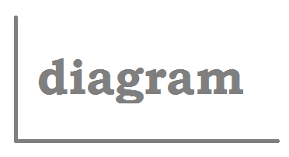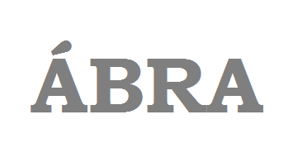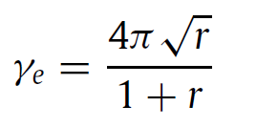

Y as the function of x; signed with ….

$$τ=∆t\frac{u_{2}-u_{1}}{H}$$

Parameters

* In general there is some quantitatively defined parameter to investigate
* Here has to be described
  + e.g. the *y(x)* equation
  + or a *„C”* constant…
  + or the built-up of the measuring device

*Author: Title of the most important article, Journal, Data, Volume, page

Description

Methods

* In case of experimental project: about the test rig; measured data; accuracy
* In case of 1D simulations: about the numerical method, discretization
* In case of CFD: about the software; geometry; mesh; used turbulence model…

Problem, Phenomenon

* First task to understand the phenomenon
* Due to that literature survey needed*
* It has to be presented the problem…
* The governing equations….
* The test rig…
* ….

MATERIALS AND METHODS

* This is to learn how to present your semester work by poster presentation
* Not only the work is important but the presentation too
* …
* …

AIM:

One sentence about the aim of the given, solved problem.

About the template

* The TITLE’s format is *Stílus1*
* The section titles are not be changed
* The other titles format are *Stílus2*
* The text can be formatted in *Normál1* or *Lista1* style
* For figure caption the *Képaláírás1* style is useable
* Only black text is acceptable
* Using this template is mandatory
* Changing the colours or the fragmentation of the document is forbidden
* The size of the fragments and paragraphs can be changed
* Using any columns (1 or 2) is possible
* The amount and place of the figures, pictures, illustrations, sketches or diagrams are optional

Figure 2:

Figure 1:

* First conclusion
* Second conclusion
* …
* The poster has to be submitted in **pdf via e-mail to the supervisor**, and bring for the presentation **in A3 size** printed

Further possibilities:

* Questions, tasks, ideas for the future….
* **Every red text here have to deleted or overwritten!!!!!!!!!!**

CONCLUSIONS

Title - Template

Author: John DOE (MSc student), Jane DOE

Supervisor: Joe DOESUPERVISOR

Hemodynamics subject

BME, Department of Hydrodynamic Systems, Spring 2017.

RESULTS

INTRODUCTION